Test Application Form
Testing Facility for Market Data Vendors/ End-Users/ Application Service Providers (ASPs) (collectively “Clients”)
(for direct connection Clients with HKEX Information Services (China) Limited (“HKEX-IS (CHINA)”))

To: Connectivity Project & Support, Data Business, HKEX
Email: IVSupport@hkex.com.hk Tel: (852) 2211 6558

Before submitting this Test Application Form, please check if the submission is applicable / necessary to you by referring to the Appendix below.

We would like to book the testing environment for the service as indicated below:

Our Test Purpose is:
- For Others (please specify):

Datafeed | Test Environment | Weekday/ Weekend | Dates | Number of Calendar Month* / Day
OMD-D DF | Weekday  Weekend | Weekday | Example A: From 02 Dec 2024 to 06 Dec 2024 | 5 day(s)
IIS | Weekday  Weekend | Weekend | Example B: From 07 Dec 2024 to 07 Dec 2024 | 1 day(s)
OMD-C SS | Weekday Weekend | Both Weekday & Weekend | Example C: From 01 Dec 2024 to 31 Jan 2025 | 2 month(s)
 | Weekday  Weekend |  | From to
 | Weekday  Weekend |  | From to
 | Weekday  Weekend |  | From to
 | Weekday  Weekend |  | From to
 | Weekday  Weekend |  | From to
 | Weekday  Weekend |  | From to
 | Weekday  Weekend |  | From to

* Weekend is included in the booking of whole Calendar Month, subject to the availability of the weekend production environment.
Conditions:

- New/ Existing Clients can perform End-to-End (“E2E”)/ Readiness**/ Certification Test with their testing line(s) from Mon to Fri while Existing Clients can perform testing with their production line(s) only on weekend, subject to the availability of our testing environment and discretion of HKEX-IS (CHINA). Upon receipt of the form, HKEX-IS (CHINA) will confirm the testing slot and the associated test charge. A demand note will be issued for test charge payment. Payment made would not be refundable.

- Test charge (subject to change by HKEX-IS (CHINA) without prior notice):

Free Testing Time:
(I) 20 free test days are offered to the following Clients for testing new application. If these Clients subsequently decide not to complete the corresponding production release for any reason, the 20 days free testing time will become chargeable.
- New Clients;
- Existing Clients applying for new datafeed product;
- Existing Clients applying for new connection/ RTSID; or

(II) 5 free test days per market per calendar year are offered to existing Clients.

Chargeable Testing Time: New/ Existing Clients will be charged for testing time beyond the above free test days:

Datafeed*** | Test Charge
OMD-C SS, SP, SF | - HK$1,500 for each calendar day; or  - HK$21,000 for each calendar month
MMDH | - HK$1,500 for each calendar day; or  - HK$21,000 for each calendar month
OMD-D D-Lite^, DS, DP, DF  ^Applicable to ASPs, HKFE/ SEHK Options Trading EP Vendors or End-Users only | - HK$500 for each calendar day; or  - HK$7,000 for each calendar month
IIS | - HK$500 for each calendar day; or  - HK$7,000 for each calendar month

- Test charge and test application form arrangement for OMD-C Clients who are Exchange Participants (“EPs”) of SEHK or OMD-D Clients who are EPs of HKFE/ SEHK Options Trading (collectively “EP Clients”) effective 1 Jan 2025:

Weekday Testing:
a) E2E Test: Market data test charge and test application form are waived for the respective market EP Clients.
b) Readiness Test: Market data test charge and test application form are required for EP Clients, the charging scheme would follow Condition 2 above.
Weekend Testing:
c) OTP-C Monthly Broker Test: Market data test charge and test application form are waived for SEHK EP Clients.
d) Other Test: (i) Market data test application form and (ii) OTP-C/ HKATS test booking form for the same test period are required from EP Clients for market data test charge waiver. If 3d)(ii) is not available, test charge is applicable per Condition 2 above.

- Test application including rescheduling must be submitted at least 2 business days in advance.

- Booked test day(s) will be counted for no show or cancellation notice within 2 business days.

** For difference between OMD-C/ OMD-D E2E and Readiness Test environments, please refer to the OMD Connectivity Guide on our OMD-C & OMD-D web corner.
*** Market data test booking and test charge are waived for OMD-China Connect (“OMD-CC”) test environment.

Privacy Policy Statement:

- The Vendor/ End-User/ ASP consents to the processing of personal data in accordance with the appended Privacy Policy Statement.

Submitted for and on behalf of the Vendor/ End-User/ ASP:

Company Name | : |  | Signature with Company Chop:
EP ID/ Customer Code  (for EP only) | :
Contact Person Name | :
Title | :
Contact No. | :
Date | :

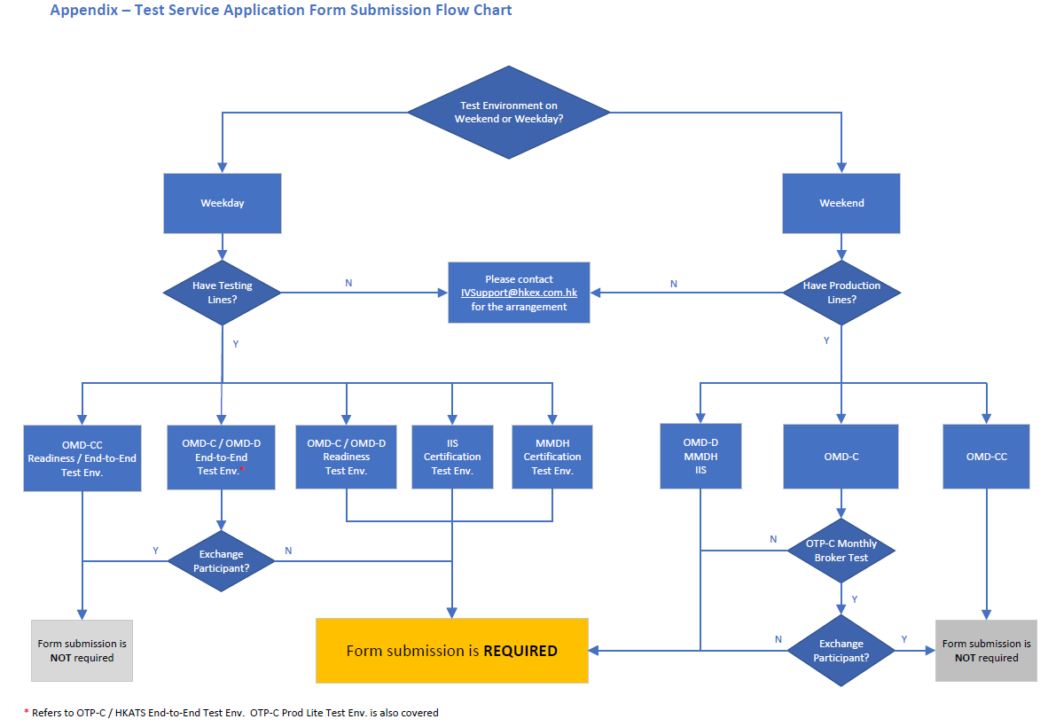

Privacy Policy Statement

Hong Kong Exchanges and Clearing Limited, and from time to time, its subsidiaries (together the "Group") (and each being "HKEX", "we", "us" or "member of the Group" for the purposes of this Privacy Policy Statement as appropriate) recognise their responsibilities in relation to the collection, holding, processing, use and/or transfer of personal data under the Personal Data (Privacy) Ordinance (Cap. 486) ("PDPO"). Personal data will be collected only for lawful and relevant purposes and all practicable steps will be taken to ensure that personal data held by us is accurate. We will use your personal data which we may from time to time collect in accordance with this Privacy Policy Statement.
We regularly review this Privacy Policy Statement and may from time to time revise it or add specific instructions, policies and terms. Where any changes to this Privacy Policy Statement are material, we will notify you using the contact details you have provided us with and, where required by the PDPO, give you the opportunity to opt out of these changes by means notified to you at that time. Otherwise, in relation to personal data supplied to us through the HKEX website or otherwise, continued use by you of the HKEX website or your continued relationship with us shall be deemed to be your acceptance of and consent to this Privacy Policy Statement, as amended from time to time.
If you have any questions about this Privacy Policy Statement or how we use your personal data, please contact us through one of the communication channels set out in the "Contact Us" section below.
We will take all practicable steps to ensure the security of the personal data and to avoid unauthorised or accidental access, erasure or other use. This includes physical, technical and procedural security methods, where appropriate, to ensure that the personal data may only be accessed by authorised personnel.
Please note that if you do not provide us with your personal data (or relevant personal data relating to persons appointed by you to act on your behalf) we may not be able to provide the information, products or services you have asked for or process your requests, applications, subscriptions or registrations, and may not be able to perform or discharge the Regulatory Functions (defined below).

Purpose
From time to time we may collect your personal data including but not limited to your name, mailing address, telephone number, email address, date of birth and login name for the following purposes:
1. to process your applications, subscriptions and registration for our products and services;
2. to perform or discharge the functions of HKEX and any company of which HKEX is the recognised exchange controller (as defined in the Securities and Futures Ordinance (Cap. 571)) ("Regulatory Functions");
3. to provide you with our products and services and administer your account in relation to such products and services;
4. to conduct research and statistical analysis;
5. to process your application for employment or engagement within HKEX to assess your suitability as a candidate for such position and to conduct reference checks with your previous employers; and
6. other purposes directly relating to any of the above.

Direct marketing
Where you have given your consent and have not subsequently opted out, we may also use your name, mailing address, telephone number and email address to send promotional materials to you and conduct direct marketing activities in relation to HKEX financial services and information services, and financial services and information services offered by other members of the Group.
If you do not wish to receive any promotional and direct marketing materials from us or do not wish to receive particular types of promotional and direct marketing materials or do not wish to receive such materials through any particular means of communication, please contact us through one of the communication channels set out in the "Contact Us" section below. To ensure that your request can be processed quickly please provide your full name, email address, log in name and details of the product and/or service you have subscribed.

Identity Card Number
We may also collect your identity card number and process this as required under applicable law or regulation, as required by any regulator having authority over us and, subject to the PDPO, for the purpose of identifying you where it is reasonable for your identity card number to be used for this purpose.

Transfers of personal data for direct marketing purposes
Except to the extent you have already opted out we may transfer your name, mailing address, telephone number and email address to other members of the Group for the purpose of enabling those members of the Group to send promotional materials to you and conduct direct marketing activities in relation to their financial services and information services.

Other transfers of your personal data
For one or more of the purposes specified above, your personal data may be:
1. transferred to other members of the Group and made available to appropriate persons in the Group, in Hong Kong or elsewhere and in this regard you consent to the transfer of your data outside of Hong Kong;
2. supplied to any agent, contractor or third party who provides administrative, telecommunications, computer, payment, debt collection, data processing or other services to HKEX and/or any of other member of the Group in Hong Kong or elsewhere; and
3. other parties as notified to you at the time of collection.

How we use cookies
If you access our information or services through the HKEX website, you should be aware that cookies are used. Cookies are data files stored on your browser. The HKEX website automatically installs and uses cookies on your browser when you access it. Two kinds of cookies are used on the HKEX website:
Session Cookies: temporary cookies that only remain in your browser until the time you leave the HKEX website, which are used to obtain and store configuration information and administer the HKEX website, including carrying information from one page to another as you browse the site so as to, for example, avoid you having to re-enter information on each page that you visit. Session cookies are also used to compile anonymous statistics about the use of the HKEX website.
Persistent Cookies: cookies that remain in your browser for a longer period of time for the purpose of compiling anonymous statistics about the use of the HKEX website or to track and record user preferences.
The cookies used in connection with the HKEX website do not contain personal data. You may refuse to accept cookies on your browser by modifying the settings in your browser or internet security software. However, if you do so you may not be able to utilise or activate certain functions available on the HKEX website.

Compliance with laws and regulations
HKEX and other members of the Group may be required to retain, process and/or disclose your personal data in order to comply with applicable laws and regulations or in order to comply with a court order, subpoena or other legal process (whether in Hong Kong or elsewhere), or to comply with a request by a government authority, law enforcement agency or similar body (whether situated in Hong Kong or elsewhere) or to perform or discharge the Regulatory Functions. HKEX and other members of the Group may need to disclose your personal data in order to enforce any agreement with you, protect our rights, property or safety, or the rights, property or safety of our employees, or to perform or discharge the Regulatory Functions.

Corporate reorganisation
As we continue to develop our business, we may reorganise our group structure, undergo a change of control or business combination. In these circumstances it may be the case that your personal data is transferred to a third party who will continue to operate our business or a similar service under either this Privacy Policy Statement or a different privacy policy statement which will be notified to you. Such a third party may be located, and use of your personal data may be made, outside of Hong Kong in connection with such acquisition or reorganisation.

Access and correction of personal data
Under the PDPO, you have the right to ascertain whether we hold your personal data, to obtain a copy of the data, and to correct any data that is inaccurate. You may also request us to inform you of the type of personal data held by us. All data access requests shall be made using the form prescribed by the Privacy Commissioner for Personal Data ("Privacy Commissioner") which may be found on the official website of the Office of the Privacy Commissioner or via this link
https://www.pcpd.org.hk/english/publications/files/Dforme.pdf
Requests for access and correction of personal data or for information regarding policies and practices and kinds of data held by us should be addressed in writing and sent by post to us (see the "Contact Us" section below).
A reasonable fee may be charged to offset our administrative and actual costs incurred in complying with your data access requests.

Termination or cancellation
Should your account or relationship with us be cancelled or terminated at any time, we shall cease processing your personal data as soon as reasonably practicable following such cancellation or termination, provided that we may keep copies of your data as is reasonably required for archival purposes, for use in relation to any actual or potential dispute, for the purpose of compliance with applicable laws and regulations and for the purpose of enforcing any agreement we have with you, for protecting our rights, property or safety, or the rights, property or safety of our employees, and for performing or discharging our functions, obligations and responsibilities.

General
If there is any inconsistency or conflict between the English and Chinese versions of this Privacy Policy Statement, the English version shall prevail.

Contact us
By Post:
Personal Data Privacy Officer
Hong Kong Exchanges and Clearing Limited
8th Floor, Two Exchange Square
8 Connaught Place
Central
Hong Kong
By Email:
DataPrivacy@HKEX.COM.HK

